SCAR GLOBAL LIFE INSURANCE

TABLE OF CONTENTS

CHAPTER NO. | TITLE | PAGE NO.
 | ABSTRACT | 3
 | LIST OF TABLES | 5
 | LIST OF FIGURES | 5
1 | INTRODUCTION | 6
1.1 | BACKGROUND PROCESS | 6
1.1.1 | Organizational Profile | 6
1.1.2 | Purpose of the System | 7
1.1.3 | Scope of the project | 7
1.1.4 | Definitions, acronyms and Abbreviations | 8
2 | SYSTEM DESCRIPTION | 9
2.1 | Problem Statement
2.2 | Present System
2.3 | Proposed System
2.4 | Objective of the System
3 | SYSTEM REQUIREMENT SPECIFICATION | 10
3.1 | Non Functional Requirements
3.1.1 | Software Requirements
3.1.2 | Hardware Requirements | 11
3.2 | Functional Requirements
3.2.1 | Product Requirements
3.2.2 | User Requirements
3.3 | Performance Requirements | 12
3.4 | Quality Requirements
4 | SYSTEM ANALYSIS (RESEARCH) | 13
4.1 | Feasibility Study
4.1.1 | Functional Feasibility
4.1.2 | Economic Feasibility
4.1.3 | Technical Feasibility
4.2 | System Study | 14
4.2.1 | User Personas and Characteristics
4.2.2 | Product Perspective
4.2.3 | Overview of Data Requirements
4.2.4 | General Constraints, Assumptions
 | Dependencies and Guidelines
4.2.5 | User view of Product Use
 |  | 16
5 | SYSTEM DESIGN
5.1 | Data Design Diagrams
5.1.1 | Data Flow Diagram
5.1.2 | Use Case Diagram
5.1.3 | E-R Diagrams
5.2 | Functional design Diagrams | 25
5.2.1 | Functional Flow Diagram
5.2.2 | Subsystem Decomposition
5.2.3 | Activity Diagrams
5.2.4 | Sequence Diagrams
5.3 | Data Dictionary | 33
5.4 | Class Diagrams | 36
6 | DEVELOPMENT (CODING) | 37
6.1 | About Dot Net & VC# | 37
6.2 | About SQL Server | 39
6.3 | Screen (Screen Shots) | 44
6.4 | Coding | 69
7 | TESTING | 88
8 | SCOPE OF FUTURE ENHANCEMENT | 91
9 | CONCLUSION | 91
10 | BIBLIOGRAPHY | 92

ABSTRACT

PROJECT TITLE : Scar Global Life Insurance

APPLICATION TYPE: Web Application

DESCRIPTION

The main purpose of this project is to estimate some important statistics of Micro insurance in the current market of India by gathering and analyzing data which is available. The statistics will be useful to prepare better insurance plans to boost up the Life Insurance industry in India.

MODULES

- Admin module: This module allows only registered members to log in and manage the users and article.
- Registered users module: This module allows to known the premium details of the users and product details.
- Public user’s module: This module generates reports giving information about the insurance and statical information.

PROGRAMMING ENVIRONMENT

Operating System : Windows
Application type : Web Application
Development IDE : Microsoft Visual Studio 2005 with Dot Net Framework 2.0
Development tool : Visual C#.Net
Database : Microsoft SQL Server 2000

1.INTRODUCTION

1.1 BACKGROUND PROCESS

1.1.1 Organizational Profile

xxxxxxxxx is a leading global software solution company has its full-fledged offshore development and corporate training divisions in Hyderabad.

xxxxxxxxx understands the need for qualified IT professionals has been spiraling over the last decade. For over a decade now India has been the obvious destination for enterprise seeking topnotch services and solutions.
xxxxxxxxx has a broad spectrum of Fortune 500 clients hailing from medicine to communication, banking to manufacturing, services to R&D. to ensure that recruits skills and technical expertise remain relevant of all times, they are put through rigorous on the job, hands-on training in up-to-the-minute technologies ERP-SAP & Oracle, ABAP, Data warehousing, .NET, J2EE and all advanced technologies.

xxxxxxxxx possess the best credentials in their individual fields of expertise and are continuously encouraged to upgrade their technical and motivational skills through in-house training programs. Coupled with the fact that our infrastructure is more state-of-the-art than most. Our innovative technologies are second to none, and our employee-friendly policies are designed exclusively to guarantee work satisfaction. We can confidently boast of attracting the finest talent in the industry. A high-powered activity graph, blended with top-of-the-line projects ensures that their excitement and commitment remain undeterred.

1.1.2 Purpose of the System

This web site is an online micro insurance Analysis and information management system that provides easy access of information regarding the people and resources of insurance. This site is not a static site but with wonderful dynamic facilities like search tools for insurance awareness articles, guidelines, illustrations through images for visitors. This site also provides several dynamic features.

1.1.3 Scope of the Developed System

The developed system is applicable to only MIRC to provide online services to its member organizations.

1.1.4 Definitions, Acronyms, and Abbreviations

Term | Definition
MIRC | Micro Insurance Resource Center, India
Website | The proposed web site
Members | Member institutions and related persons
Product | Website, the outcome of the development
Visitor | A non registered person who can access only general information in the web site
User/Member | A registered user/associate
Web Pages | Static or dynamic pages present in the web site
HTML | Hypertext Markup Language. A language used to describe the structure of documents on the web.
Q & A | An abbreviation for "Question and Answer."
Web-based | Refers to one of the units of the whole web related technologies that is involved in a certain aspect of the project.
Universal link | Common link in all pages

2. SYSTEM DESCRIPTION

2.1 Problem Statement

The developed system should allow admin users to register insured persons with their name, date of birth, residence address, medical history and also policy details. After registering all the insured persons, website should provide management facilities like delete unwanted persons’ data. And also should provide awareness to the visitors about micro insurance through articles.

  - Present System

Most of the micro insurance organizations are not having any existing fully computerized system and they are managing the information in the form of Excel spread sheets. Data of agents, Insured persons, Policy details, insurers’ list, TPA s (third party Administrators) data, etc are maintained using Excel sheets.

The system has the following drawbacks.
- Every member organization has its own data structure
- Due to lack of centralized data structure, it is very difficult to merge the data to analyze the statistics
- Difficult to search for a data
- Possibility of duplicates, etc

2.3 Proposed System

The proposed system (phase-1) provides easy solution for the above and some other problems by providing a common and centralized database structure for all members. The developed website provides the following facilities to the admin users.

- Common Database system with common data structure
- Registrations of insured persons
- Insured Person search
- Manage insured/Registered persons
- Content Management (Articles)

2.4 Objective of the System

The main objective of the developed system is to allow admin users to register insured persons with their name, date of birth, residence address, medical history and also policy details. After giving registering all the insured persons, website should provide management facilities like delete unwanted persons’ data. And also should provide awareness to the visitors about micro insurance through articles.

3. SYSTEM REQUIREMENTS SPECIFICATION

  - NON FUNCTIONAL REQUIREMENTS

3.1.1Software Requirements

This web site requires the following software in Server (computer), clients (computers)

Server-side Requirements

Operation System : Windows 2003
Web Server : IIS 6.0(Internet Information Server)
Framework : ASP.NET 2.x frame work enabled
Database : SQL Server 2000/2005
Minimum Space : 1GB (including Database space) and may grow depends on the Customer information

Client-side Requirements

Browser : Any HTML 4.0 or prior version compliant browser with a Minimum Screen resolution of 800X600 pixels (best ewed in 1024 x 768 resolution).
JavaScript : JavaScript should be enabled in the browser

3.1.2 Hardware Requirements

The following is a list of minimum requirements on server side

Processor : Pentium III
Speed : 1.0 GHz
Memory : 256MB RAM
Hard Disk : 40GB Hard disk with minimum 4GB free space
Interface : Mouse, Keyboard

On client side any hardware that can run a web browser.

3.2 FUNCTIONAL REQUIREMENTS

3.2.1 Product Requirements

This web site is an online Micro Insurance Management System that provides the following features in this phase-1.

- Micro Insurance Awareness
- Login to admin members
- Insured persons’ registrations and management
- Awareness Articles management

Visitor Services
- Articles
- About Website
- Contact Information

Member Services
- Login
- Change-password (to remind the forgotten password)
- Insured Registrations & management
- Search for insured persons
- Article Management

    - User Requirements

The web site provides easy links for easy navigation (browse) in the site. A visitor with minimum knowledge of web browsing/surfing can access the site very easily. Due to dynamic nature of features, the members, Admin members should be able to understand the provided facilities. An online help documentation will be provided to help the users and visitors in using the facilities.

    - Performance Requirements

The following performance requirements should be maintained in the project.
- Each page in the site needs to load in a reasonable amount of time.
- Latest web techniques like Caching should be implemented to speed up the loading of dynamic pages. This will also improve on the number of simultaneous users, as connections are freed faster.

  - Quality Attributes

The following quality attributes should be maintained in the project.

Maintainability

The site's maintainability will depend on clean, easy-to-read pages. Being a Dynamic Site we need to generate the dynamic output clean and well formatted

Availability

The site should be accessible to as many browsers as possible; including text browsers.

Reliability

The reliability of the website depends on the web server it will be hosted on, and also on LOGIN mechanisms.

Security

All the necessary steps has been taken to provide security to the site by following the latest technology because all the data of all members is proprietary data of the Client’s Organization and its members (Visitors and members)

- SYSTEM ANALYSIS(RESEARCH)

  - Feasibility study

    - Functional Feasibility

The proposed/developed system is a web application and does not require any additional software requirements except hosting. A web hosting company hosts the web application in their web servers. Any client (end-user) with an internet connection and a web browsing software (at client side) can immediately start accessing/using the system. So, the system does not need any installation/setup procedure. Hence, the system is functionally feasible.

    - Economic Feasibility

Author (project stakeholder) does not need to purchase any software and hardware to host the developed system. Web hosting companies purchase and maintain all necessary hardware and software for hosting the websites. Author has to pay only hosting charges to the hosting company. When it comes to the end-user, he/she does not need to purchase any software to use the website. Now-a-days every computer’s operating system is providing built in web browser and so many web browsing software products are available in the market for free.

Only the cost that the author should bare is cost of development. Before starting the development, the development team estimates cost of development depends on the features asked by the client. If any new features to be added as per the new requirements of the client, cost of new additions are submitted to the client and after getting the confirmation from the client the new features will be added by the development team. Development team will take care of in-time delivery of the project to avoid excess cost of development due to delay.

Hence, the proposed system is economically feasible.

    - Technical feasibility

This is about acceptance of the new system by the existing end-users and employees of the system and author. The website is aiming at employees and now-a-days all of them are aware of web browsing. If any person does not have any idea of web browsing, he/she will be trained to use the system with in one hour time. So, the system can easily be accepted by any kind of end-user. Hence the proposed system is technically feasible.

  - SYSTEM STUDY

    - User Personas and Characteristics

This section gives some examples of probable users of the site.

Siva Kumar a visitor seeking awareness of Insurance.

Rahul, a representative from one of the member institutions of the Insurance, visiting the website to register their members’ information in the website.

Pallavi, a Insurance consultant who is trying to see the statistics provided in the website.

Hari, searching for a insurance consultant to see advice.

Ramarao, member of governing council who is trying to see statistics of the website.

    - Product Perspective

This web site is an online Micro Insurance Management System that provides the following features in this phase-1.

- Insurance Awareness
- Login to admin members
- Awareness Articles management

Visitor Services
- Articles
- About Website
- Contact Information

Member Services
- Login
- Change-password (to remind the forgotten password)
- Insured Registrations management
- Article Management

    - Overview of Data Requirements

At the time of registration a data entry admin user should provide adequate information about the insured person like personal details, residence details, medical history, policy details and policy maximums.

    - General Constraints, Assumptions Dependencies, Guidelines

The web site provides easy links for easy navigation (browse) in the site. A user with minimum knowledge of web browsing/surfing can access the site very easily. But, due to dynamic nature of the website the user should be able to understand the system and tools provided.

If a user feels any difficulty in understanding any feature, he/she can go through the help provided in different levels.

Also, if any user is unable to find required information in the web site, he/she can contact the Experts using ASK page.

The browser at client side should enable Java script, because of implementation of java-based client side technology. For the browsers, in which java script is disabled, a page will be displayed to explain the procedure to enable java script.

    - User View of Product Use

Mr. Sravani, a visitor trying to check his stress level and seeks suggestions from the System can do the following activities in the website

- Submits registration
- Contacts expert for suggestion using Ask-Expert service

Mrs. Ragini, a registered member of the website can do the following activities

- Records responses to the questionnaires
- Gets reports and guidelines
- Goes through the management articles
- Compares and analyses the previous audits

- SYSTEM DESIGN

  - DATA DESIGN DIAGRAMS

UML is a latest concept of presenting various diagrams of a project. UML stands for Unified Modeling Language.

The purpose of this section is to show the following type of conceptual/logical diagrams of the proposed project.

- Data Flow diagram of the project
- Use case diagrams
- Activity diagrams

Data flow diagram explains the overall view of utilization of user’s data in different levels/modules of the project. Use case diagrams explain main entities and their features. Activity diagrams explain the main activities/processes present in the project.

    - DATA FLOW DIAGRAM

Content Admin
Analysis system

Claims

Renewals

Web Content
Data of Insured Person
Personal data

Health history

Insurance Details

Data of Co-insured person

USE CASE DIAGRAMS

5.1.2.1 Use Case Diagram: Visitor and Facilities

Home Page
About Page
Contact Page
Articles Page
Public Pages

Visitor
(Unregistered User)

5.1.2.2 Use Case Diagram: Online Registered Members and Facilities

Public Pages

Secured Pages

Login & Forgot Password

Change Password

Manage Insured person’s
Content Admin
(Data Managing User)
Search Tool

Manages Articles

5.1.2.3 USE CASE RELATIONSHIP DIAGRAMS

Job seeker (unregistered)
Requests
Process
<<Includes>>
Admin
<<Extends>>
Visitor

Account
Management
(Upload, Block, Unblock, delete)
<<Includes>>
<<Extends>>

Member

Admin

    - Entity Relation (ER) Diagrams

ER (Entity Relation) diagrams

An ER diagram gives a clear idea of logical relation between two or more entities. These diagrams help us to understand the technical design of database involved in the project.

The following relational diagrams show the logical relation between the entities.

5.1.3.1 Insured Person’s details diagram

Insured Person
Personal details
Has
1
1
Residence History
Has
n
1
Occupation History
Has
n
1
Medical History
Has

Insured Person – Personal details relation

Insured Person
Identity
Personal details
Has
1
1
Name
Gender
Family enter date
Family exit date
Date of Birth/Age
Relation ship

5.1.3.3 Insured Person – Residence History relation
Insured Person
Residence History
Has
n
1
Identity
Residence Date
Village
District
State
Block
Pin

5.1.3.4 Insured Person – Occupation History relation

Insured Person
Identity
Occupation History
Has
n
1
Occupation Date
Occupation
Industry

5.1.3.5 Insured Person – Medical History relation

Insured Person
Identity
Medical History
Has
n
1
Diagnosis Date
Disease (ICD code)
WAIVER of 1stYEARs EXCLUSION

5.1.3.6 Claims diagram
Claim
Insured Person
Has
n
1
POLICY+ENDORSEMENT NO.#

CLAIM ID
OLD CLAIM NUMBER
INSURED IDENTITY
INCURRED DATE
REPORTED DATE
DATE OF CLAIM PAID
DATE OF ADMISSION
DATE OF DISCHARGE
CLAIM STATUS
REASON FOR DENIAL

TOTAL CHARGES
TOTAL DEDUCTIBLE PAID
TOTAL CO-INSURANCE PAID
TOTAL EXCLUDED AMOUNT

TOTAL EXCEEDED AMOUNT

TOTAL BENEFIT PAID
TOTAL PRE-HOSP.CHARGES
TOTAL POST-HOSP.CHARGES

CLAIM CHARGES
EXCEEDED AMOUNT
DEDUCTIBLES PAID
EXCLUDED AMOUNT
Has
1
1
Has
1
1
Has
1n
1
Has
1
1
CLAIM PAID AMOUNTS
Has
1
1
CLAIM DIAGNOSIS
Has
1
1
FUNCTIONAL DIAGRAMS

FUNCTIONAL FLOW DIAGRAM

Start
Admin logs in
Registers insured persons’ data
Search and Manages insured persons’ data
Manages and
Uploads Articles
Stop
Login is Success
Login is not succeeded
Can browse only articles and public pages
Log out

Subsystem decomposition

This section shows the all-functional objects in the project and their functionality.

The following list of functional object as identified in the project.

- Login
- Register an Insured persons data
- Manages Insure Persons data
- Manages Articles
ADMINS
LOG IN
CHANGE PASSWORD
MANAGE INSURED PERSONS
ARTICLE MANAGEMENT
INSURED REGISTRATION
PERSONAL DETAILS
MEDICAL HISTORY
POLICY DETAILS
POLICY MAXIMUMS

SEARCH TOOL
QUICK SEARCH
SEARCH RESULTS
ADVANCED SEARCH

MANAGEMENT
DELETE AN INSURED PERSON
ADD A NEW INSURED PERSON

ARTICLES MANGEMENT
MANAGE ARTICLES
UPLOAD ARTICLES

Activity diagrams

ACTIVITY DIAGRAM OF ADMIN ACTIVITIES

Admin login fail

Insured Registrations

Admin login success
Manage Registrations

Database
Search tool

Upload Articles

- Upload images for web site pages to images folder

Logout

Admin activities are completed

SEQUENCE DIAGRAMS

5.2.4.1 NEW INSURED REGISTRATION

Admin
Add New Insured link in main Page
Registration Page
Registration data
Press ( )
Show ( )
View ( )
Fill details ( )
Submit details ( )
Save details ( )
Displays new registration ID ( )
Response ( )

5.2.4.2 MEMBER/ADMIN LOGIN

Member/Admin
Login Control
Login Button
Member data
View ( )
Fill details ( )
Submit details ( )
Verifies ( )
If verification succeeded, shows ( )
Press ( )
Main Form
If verification failed, shows error message

5.2.4.3 INSURED MANAGEMENT

Admin
Press ( )
Show ( )
View ( )
Select Members ( )
Press Delete button ( )
Deletes Registrations()
Displays Remaining list ( )
Members List ( )
Insured Persons Management button
Members Management form
Member’s data
Members List ( )

5.2.4.4 ARTCLES MANAGEMENT

Members
Press ( )
Show ( )
Select Articles ( )
Press Delete ( )
Submit for delete ( )
Display Remaining Articles ( )
Responses ()
Articles management link in main page
Article Management Page
Articles data
Articles List ( )
View Articles ( )

DATA DICTIONARY

5.3.1 Table Name: tblInsured

Column Name Data Type Constraint
InsuredID int PK
Name varchar (50) NOT NULL
Gender varchar (7) NOT NULL
DOB datetime NOT NULL
FEnterDate datetime NULL
FExitDate datetime NULL
Industry varchar (50) NOT NULL
Occupation varchar (50) NOT NULL
Block varchar (50) NOT NULL
Village varchar (50) NOT NULL
District varchar (50) NOT NULL
State varchar (50) NOT NULL
pin varchar (7) NOT NULL
NomineeName varchar (50) NOT NULL
NomineeRelation varchar (50) NOT NULL
NomineeAge numeric(3) NULL

5.3.2 Table Name: tblMedicalHistory

Column Name Data Type Constraint
SNo int PK
InsuredID int NULL
DDate datetime NOT NULL
Disease varchar (100) NOT NULL

5.3.3 Table Name: tblPolicyDetails
Column Name Data Type Constraint
PolicyNumber varchar (20) PK
InsuredID int NOT NULL
Insurer varchar (50) NOT NULL
TPA varchar (50) NOT NULL
TypeOfCover varchar (30) NOT NULL
EffectiveDate datetime NOT NULL
ExpiryDate datetime NOT NULL
PremiumRate numeric(10,2) NULL
PremiumMode varchar (30) NULL
Maternity varchar (1) NULL
BabyCover varchar (1) NULL
BabyCoverDaysStart numeric(3 0) NULL
PreHospiDays numeric(1) NOT NULL
PostHospiDays numeric(1) NOT NULL
PolicyMax numeric(10,2) NOT NULL
PolicyDeductible numeric(10,2) NOT NULL

5.3.4 Table Name: tblPolicyMaximums
Column Name Data Type Constraint
PolicyNumber varchar (20) NOT NULL
OPMax numeric(10,2) NULL
AmbulanceMax numeric(10,2) NULL
CheckUpMax numeric(10,2) NULL
RoomMax numeric(10,2) NULL
Nursing numeric(10,2) NULL
IcuMax numeric(10,2) NULL
OperatingRoomMax numeric(10,2) NULL
DoctorChargesMax numeric(10,2) NULL
DrugsMax numeric(10,2) NULL
InvestigationMax numeric(10,2) NULL
DiagMax numeric(10,2) NULL
ConsumablesMax numeric(10,2) NULL
OthersMax numeric(10,2) NULL

5.3.5 Table Name: MasterIndustries
Column Name Data Type Constraint
Industry varchar (50) PK

5.3.6 Table Name: MasterInsurers
Column Name Data Type Constraint
Insurer varchar (50) PK

5.3.7 Table Name: MasterOccupations
Column Name Data Type Constraint
Occupation varchar (50) PK

5.3.8 Table Name: MasterRelations
Column Name Data Type Constraint
Relation varchar (50) PK

5.3.9 Table Name: MasterStates
Column Name Data Type Constraint
State varchar (50) PK

5.3.10 Table Name: MasterTPA
Column Name Data Type Constraint
TPA varchar (50) PK

5.3.11 Table Name: Articles
Column Name Data Type Constraint
sno int PK
title varchar (50) NOT NULL
fname varchar (255) NOT NULL

5.3.12 Table Name: tblSuperAdmin
Column Name Data Type Constraint
UserID varchar (20) Primary Key
Password varchar (20) NOT NULL

CLASS DIAGRAMS
Policy Details
+ PolicyNumber: string
+ InsuredID: int
+ Insurer: string
+ TPA: string
+ TypeOfCover: string
+ EffectiveDate: datetime
+ ExpiryDate: datetime
+ PremiumRate: double
+ PremiumMode: string
+ Maternity: short
+ BabyCover: short
+ BabyCoverDaysStart: short
+ PreHospiDays: int
+ PostHospiDays: int

1 1
Insured Person
InsuredID: int
Name: string
Gender: string
DOB: datetime
FEnterDate: datetime
FExitDate: datetime
Industry: string
Occupation: string
Block: string
Village: string
District: string
State: string
pin: string
NomineeName: string
NomineeRelation: string
NomineeAge: short
Admin
+ UserID: string
+ Password: string
+ Role: string
+isLoginExists(uid,pwd)
+ GetAllInsureds ( )
+ GetDetailsOf(insuredID)
+ ChangePassword(…)
+ DeleteInsureds(list)
+ AddInsured(…)
+ GetAllArticles()
+ DeleteArticles(list)
+ AddArticle(list)
n 1
+ PolicyMax : double
+ PolicyDeductible: double
+ OPMax: double
+ AmbulanceMax: double
+ CheckUpMax: double
+ RoomMax: double
+ Nursing: double
+ IcuMax: double
+ OperatingRoomMax: double
+ DoctorChargesMax: double
+ DrugsMax: double
+ InvestigationMax: double
+ DiagMax: double
+ ConsumablesMax: double
+ OthersMax: double
Policy Maximums
1 1

- DEVELOPMENT (CODING)

About Dot Net & VC#

Dot Net

It is also called as Microsoft.Net. It is a new programming platform for software development with new generation of computing facilities. The plat form is called Dot Net Framework. Microsoft started development of the new platform in late 90s (after release of Visual studio 6.0 in 1998) under the name Next Generation Windows Services (NGWS) and later named as Dot Net Framework.

S.No.# | Version | Released on
1 | 1.0 (Beta 1) | November 2000
2 | 1.0.2914.0 (Beta 2) | 20th June 2001
3 | 1.0 (RTM) | 05th January 2002
4 | 1.0.3705.209 (SP1) | 19th March 2002
5 | 1.0.3705.288 (SP2) | 07th August 2002
6 | 1.0.3705.6018 (SP3) | 31st August 2004
7 | 1.1.4322.573 (RTM) | 01st April 2003
8 | 1.1.4322.2032 (SP1) | 30th August 2004
9 | 1.1.4322.2300 (SP1 for Windows Server 2003) | 30th March 2005
10 | 2.0.50727.42 (RTM) | 07th November 2005
11 | 3.0.4506.30 (RTM) | 06th November 2006
12 | 3.5.20706.1 (Beta 2) | 26th July 2007

Notes:
- Beta version is a trial version
- RTM (Release to Manufacture) is a stable version
- SP (Service Pack) version is a version, which is released by fixing bugs.
- In the above table the highlighted (bold) versions are stable and widely used in the market for development
- Version 3.0.x is released for prior versions of windows OS 2000 and XP SP1

New concepts

This platform has a rich set of new programming concepts. The following are the new concepts in dot net apart from the other programming concepts.

- XML formatted data transfer between objects
- GDI+ (Improved Device Independent Graphics Technology)
- COM+ (improved Component Object Model)
- Interoperability (Communication between Old and New Applications)
- Language Independence (Components prepared in one dot net based language can be used in another dot net based language without any conversion).
- Disconnected Database Architecture (ADO.NET)
- Improved web application development (ASP.NET)
- Web services and Remoting for rich and unblocked communications
- Improved security in Standalone and web applications
- And etc.

Visual Studio

It is an Integrated Development Environment (IDE), developed by Microsoft, to create Standalone applications, web applications (ASP: Active server pages) and web services. It is a combination of different development tools like (Visual Basic, Visual C++…)

Advantages

- Windows forms and Web pages can be created with just drag and drop of components very quickly without spending much effort.
- Built-in editor with intellisense to assist user while programming. Intellisense technology facilitates user by displaying context menus with programming command and words, highlighting key words, auto completing key words and user created words, etc …
- Built-in debugging facilities to find and rectify the bugs quickly by moving between line by line in the code at run time (while the program is running) and also using watch window, debug window, etc.
- Integration of list of all related files in the project
- Time to time tracking of all modifications of project

Visual C#

It is pronounced as Visual C Sharp. In musical notes the symbol # is called sharp. This language is a product of Microsoft and coming along with visual studio as one of the development tools like VB, VC++. VC# is a combination of c++, JAVA programming features and productivity features of highly productive language Visual Basic. So, using VC# we can develop projects with quickly (high productivity), security. The language allows development of all types of software products. Some of them are listed as follows.

- Windows applications (GUI applications)
- Console applications (CUI applications)
- Web applications
- Mobile applications
- Network/communication applications, etc

About SQL Server 2000

It is also pronounced as Sequel server. This is a client-server database management system developed by Microsoft for large scale databases. It comes into RDBMS (Relational Database Management System) category. It works based on SQL (System query language), a latest and advanced database language.

Authentication
A user need to login to this software system in-order to manage the database. SQL server allows us to logon in two ways.

- Windows authentication
- SQL Server authentication

In windows authentication, system recognizes the user through his/her windows login credentials. That means, if a user logs into a windows operating system, he/she becomes an authorized user to use all resources that accept windows authentication and available in the system. If the logged in computer is configured as a valid client under a DNS (domain name server), the user becomes eligible to access any resource of any computer that is working under the DNS with widows authentication. In front end (programming) the following connection string can be used to connect to the server.

Server=[server name] ; initial catalog=[database name]; trusted_connection=true;
In SQL server authentication, user will be provided a user id and password. A user from any system in the network can use the user id and password to connect to the database server. In front end (programming) the following connection string can be used to connect to the server.

Server=[server name] ; initial catalog=[database name]; user id=[user id]; password=[password];

Features of SQL Server

- License cost is very lower than any RDBMS Systems
- Runs under Windows all windows servers (NT/2000/2003)
- Runs under client versions Windows 95/98/XP … (to install server service, we need to install MSDE – Microsoft SQL Desktop Engine)
- Scalable to meet Enterprise level databases
- Supports data replication
- Supports Data Marts and Data Warehouses
- Provide OLAP service
- English Query tool makes data move available to casual users
- Data transmission services enable easy exchange of data
- Supports distributed transaction
- Centralized management
- Availability of Visual administration tools and wizards
- Generation and transmission of data in XML format

Advantages of relational databases

- Redundancy can be reduced
- Inconsistency can avoided
- Irrelevant data can be avoided
- Data can be shared
- Standards can be enforced
- Security restrictions can be applied means access levels can be defined
- Integrity can be maintained
- Conflicting requirements can be balanced

SQL Server Database objects

In a SQL server the following database objects can be created and maintained.

- Database Users (user accounts)
- Databases
- Tables
- Views
- Constraints
- Indexes
- Triggers
- Stored procedures
- Stored functions

DATABASE USERS

A database user is an authenticated user and allowed to logon to the server to use a set of privileged (authorized) database objects. Administrator (user id: sa) or any user having administrator privileges can access all objects without any access restrictions. Any normal user will get limited access on some very important database objects. The following list shows the general access privileges on objects.

- SELECT
- CREATE
- INSERT
- UPDATE
- DELETE

A person who creates and maintains his/her database objects is called owner of those database objects. He can GRANT or REVOKE privileges on his/her objects to other users.

DATABASES

A database is a collection of database objects. It is a container to all tables, views, indexes, constraints, triggers, stored procedures and functions. All related objects of a database of an organization are maintained as a database. Every database is maintained by the server in the form of two files. One is a database file with .mdf and another is a log data file with extension .ldf. These files can not be accessed by any other user except administrator of the system.

TABLES

A table is an actual data storage object and used to store the raw data of an entity. A table collects data in the form of rows (records) and columns (fields). So, while creating a table a user has to declare the columns in terms of column name, column type and width. Column name is a identity name of the column, column type specifies the type of data to be allowed in to the column and column width specifies the maximum number of characters or range of data to be allowed in to the column. A table allows a maximum of 1024 columns and with an unlimited number of rows.

VIEWS

A view is a filter defined on a table. A view behaves like a table but with restricted columns and rows. A view can be used to insert, update and delete the contents of a table. But all actions work under the condition (filter) defined in the view. That means we can not delete, update records that are not coming under the filter definition of the view. So, views are very useful to restrict columns and rows from the users depend on their accessibility.

CONSTRAINTS

These are a set of logical conditions built on the business logics of an organization to allow and maintain data in tables. A data that is violating these rules can not be allowed into any table of the database. These are defined on columns and rows while creating the tables. They are listed below.

Column level constraints
- Not null : Column becomes Mandatory
- Unique: Column does not allow duplicate data
- Primary key: Column becomes default field with Unique and Not null natures
Row level constraint
- Check (logical expression)
Relational constraint (between two tables)
- Foreign key/Reference Key constraint

INDEX

An index is a database object that helps the database to speedup the data search in a table. It holds a data expression/data from one or more columns of a table in ascending order to find records quickly based on values of those columns. For a table an index will be created automatically on its primary key column data. It is called clustered index which is having data from the primary column in ascending order along with cluster IDs (physical locations on the disk) of all the rows. When a search condition is applied on a table through this column, system searches the corresponding index for the rows. So, indexes make the data searching faster.

TRIGGERS

A trigger a program that will implicitly (automatically) executed by the server when a transaction (INSERT/DELETE/UPDATE) occurs of a table. They are defined on tables. They are having the following advantages.

- Deleted rows can be automatic backed-up from a table into its backup table.
- Old values can be automatically backed-up when some rows are updates with new values.
- Special business logics (constraints), that can not be implemented using standard constraints and need extra procedures, can be implemented using trigger procedures.

STORED PROCEDURES AND FUNCTIONS

These are the procedures created and stored in database separately. They are not attached to any table in the database. They take value through parameters. Some parameters are used to take data into the procedure or function, this type of parameters called in parameters. Some parameters returns values to calling programs, this type of parameters called out parameters. Stored functions can return a value or table. Stored procedures are used to add data to multiple tables with one transaction. Mainly these stored procedures and functions are used to perform tasks programmatically.

SCREEN SHOTS

In the following section a sequence of screen shots are provided from the developed system. And also some code snippets are provided to explain some important code logic.

HOME PAGE

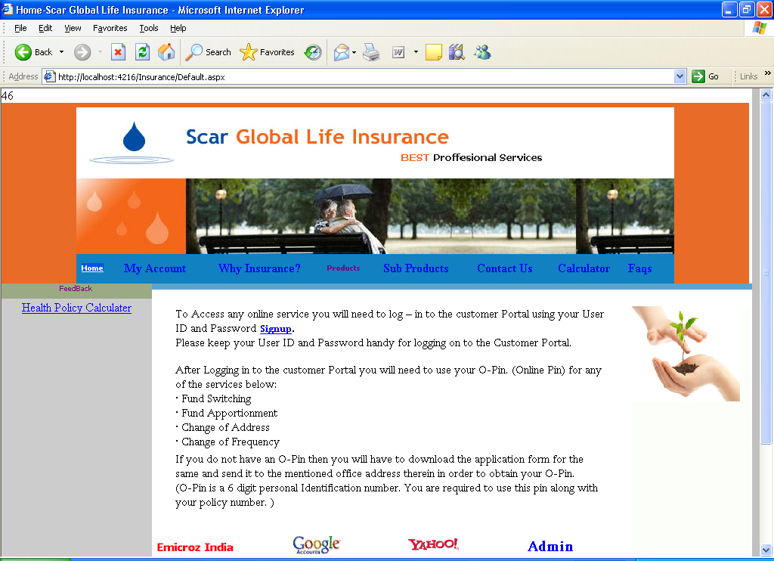

INSURANCE ARTICLES PAGE

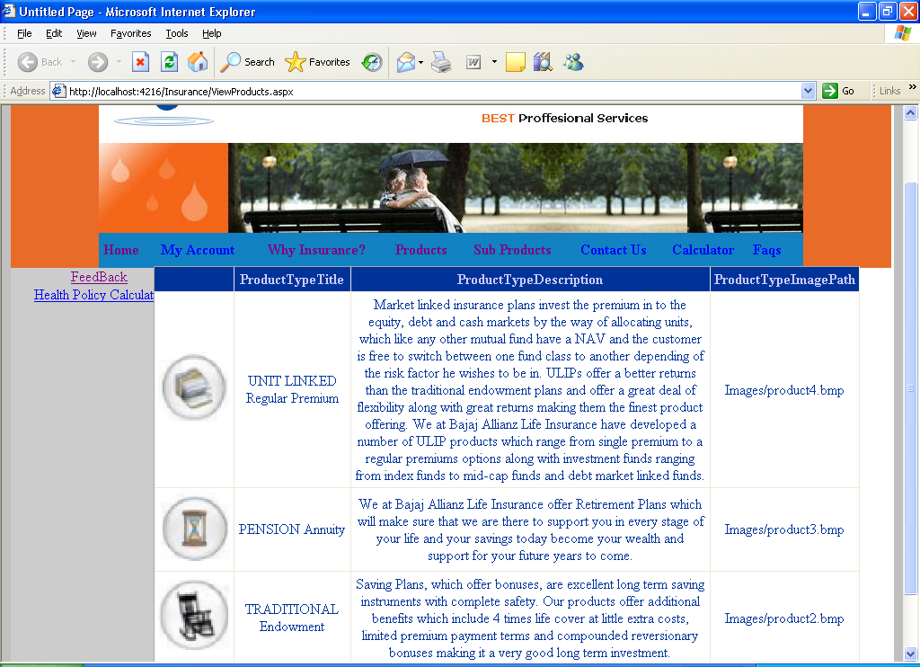

View SubProducts Page:

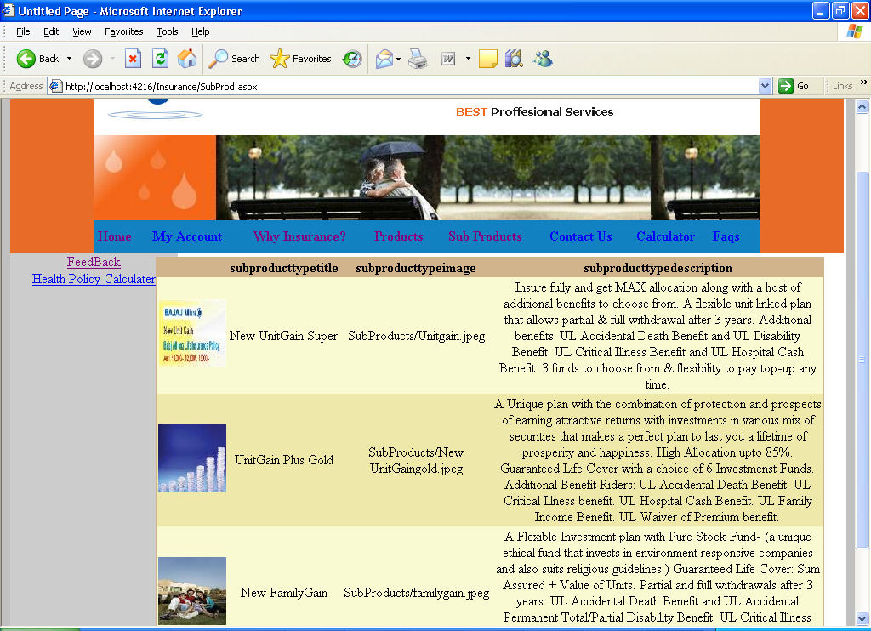

Registration Page:

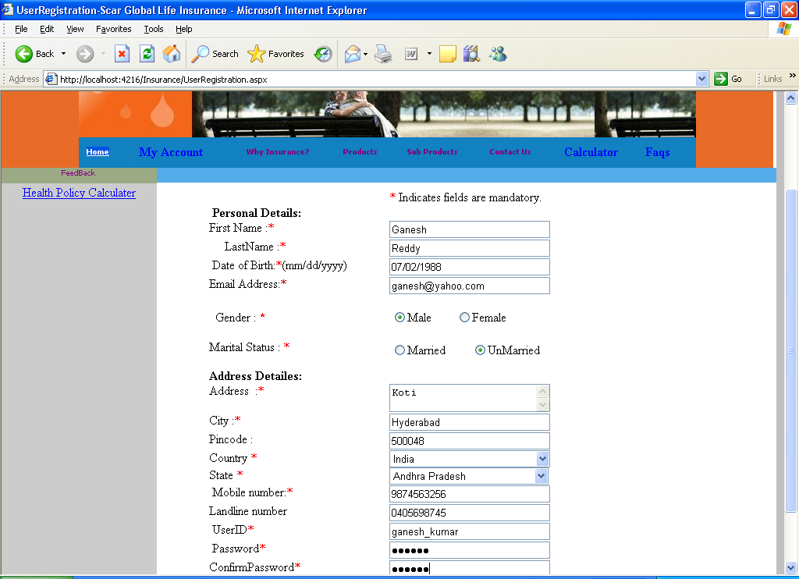

User Login:

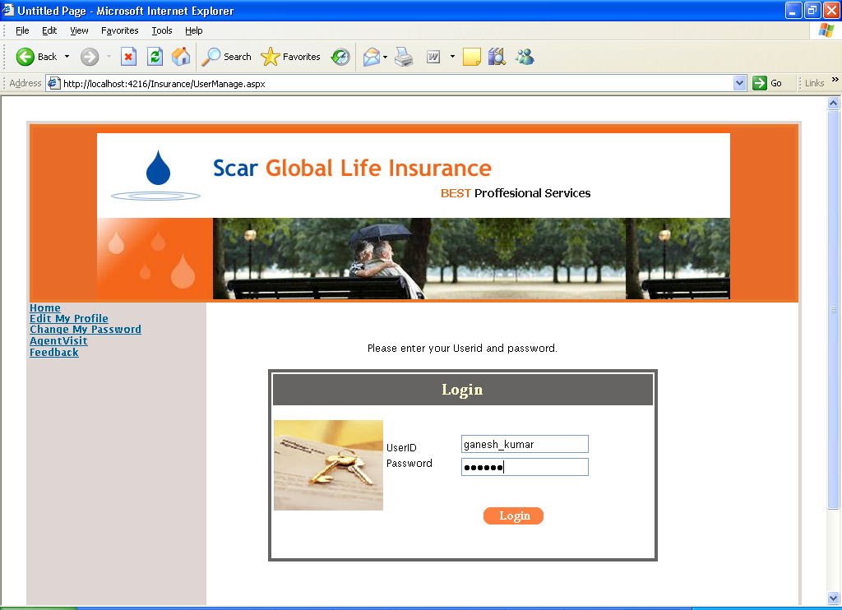

Agent Visit:

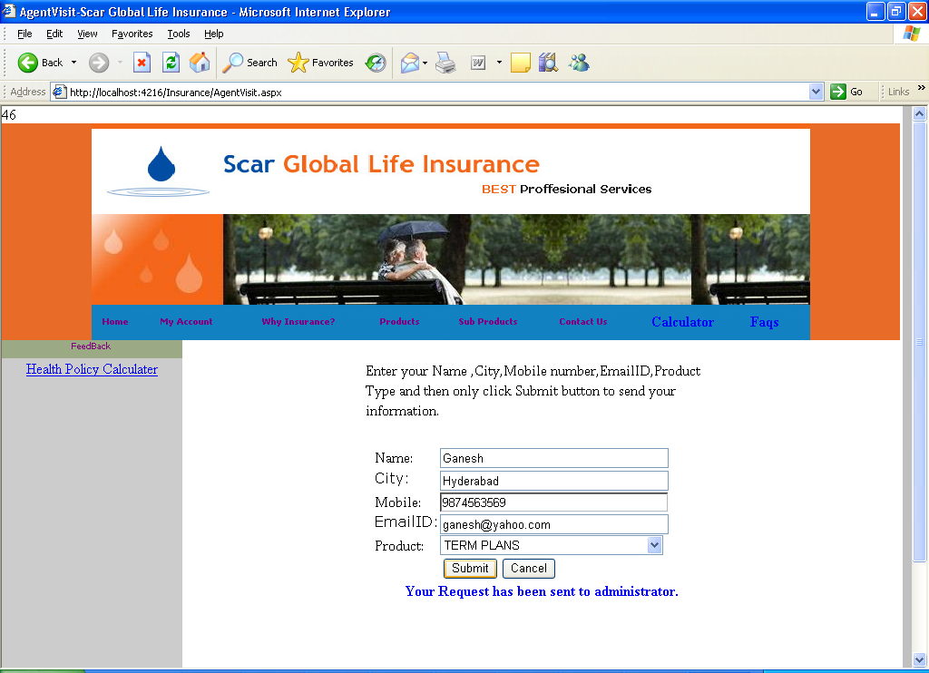

Feedback:

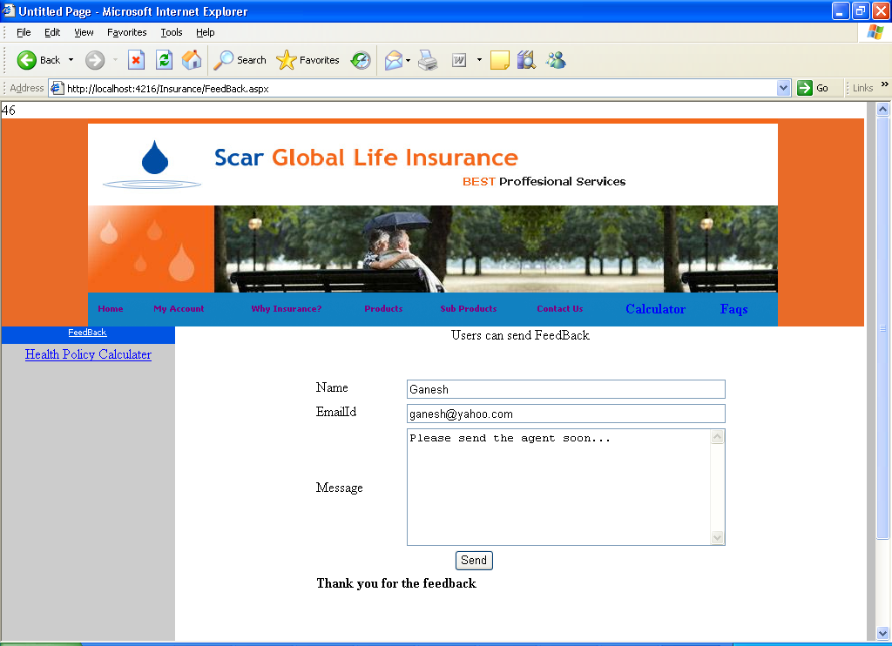

ADMIN LOGIN PAGE

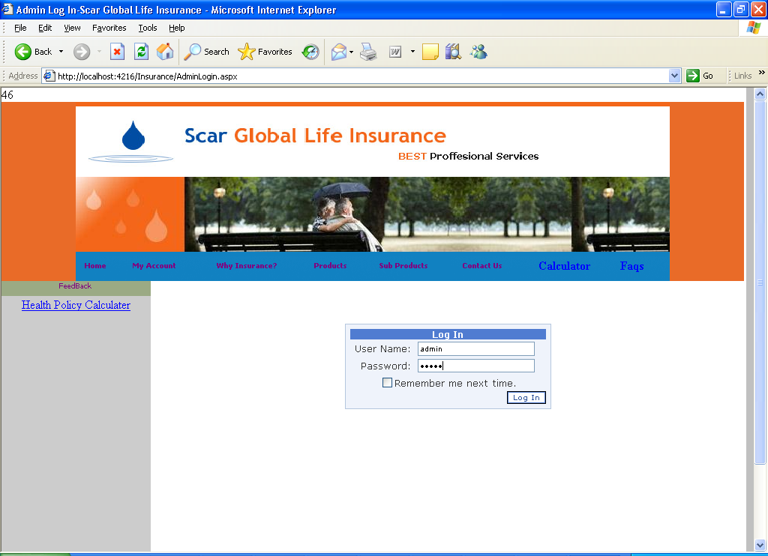
Add Product:

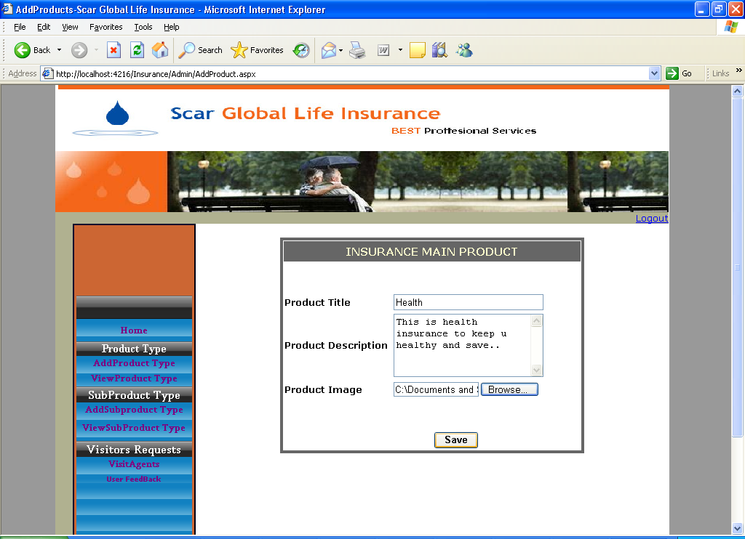

View Product:

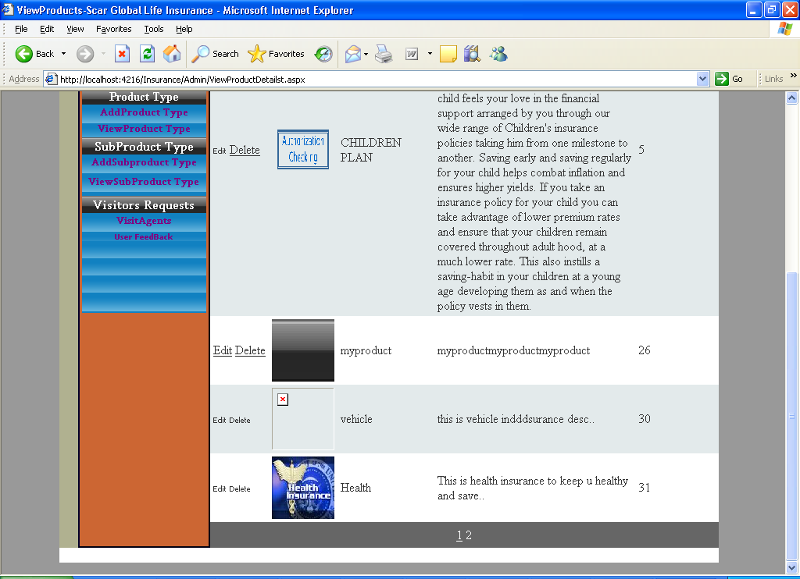

Add Subproduct Type:

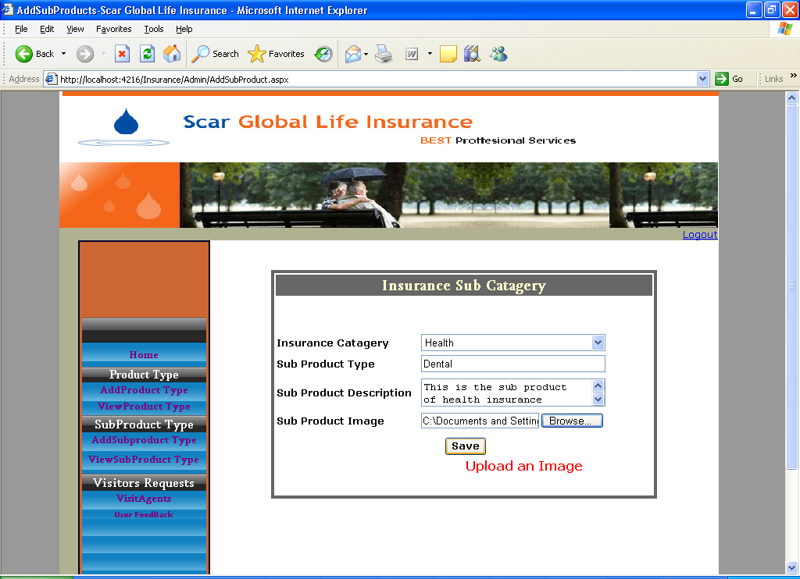

View Sub Product:

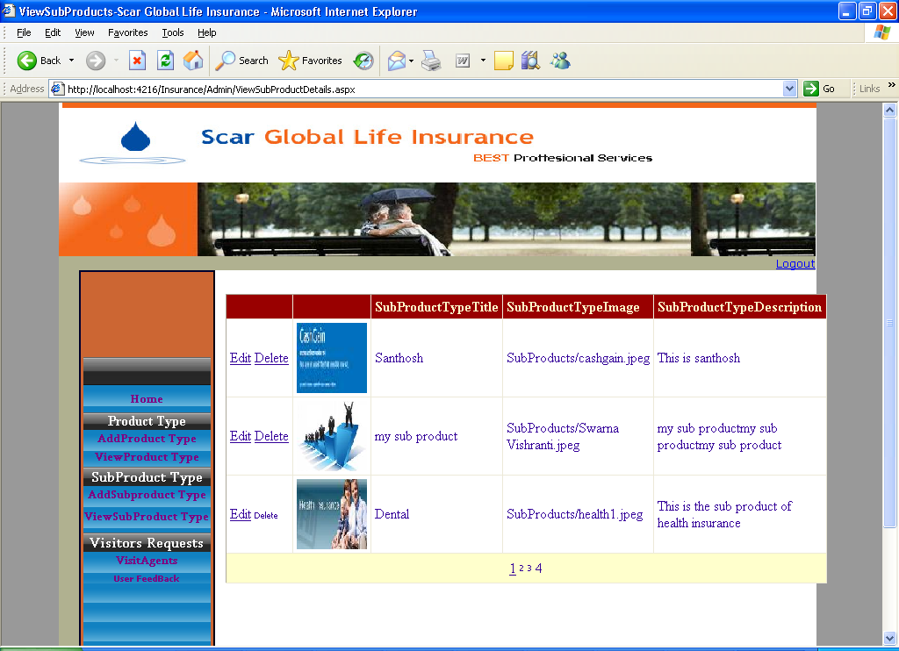

View Agent requests:

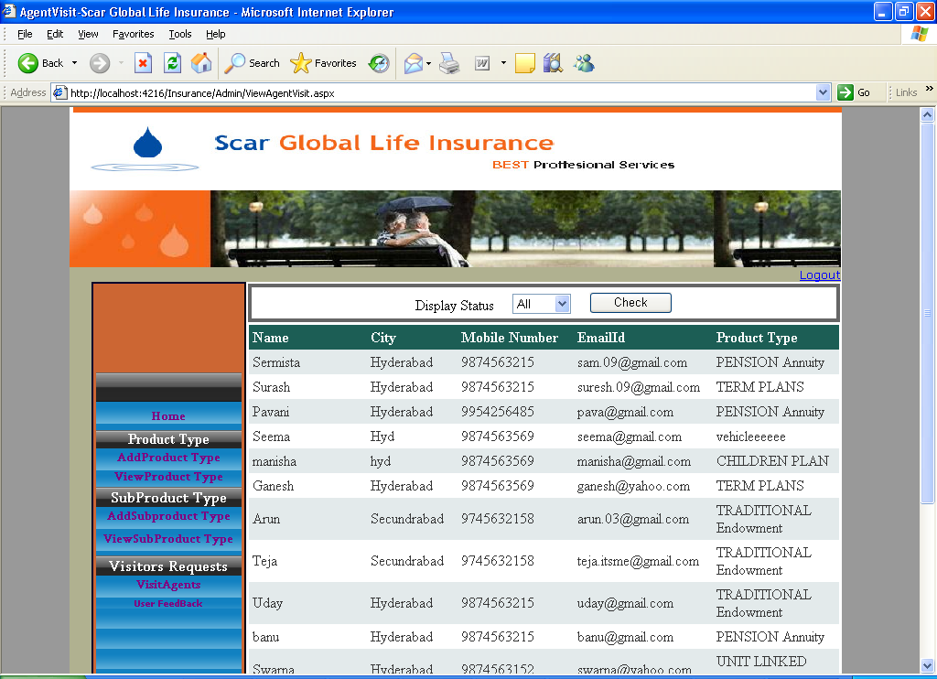

View Feedback:

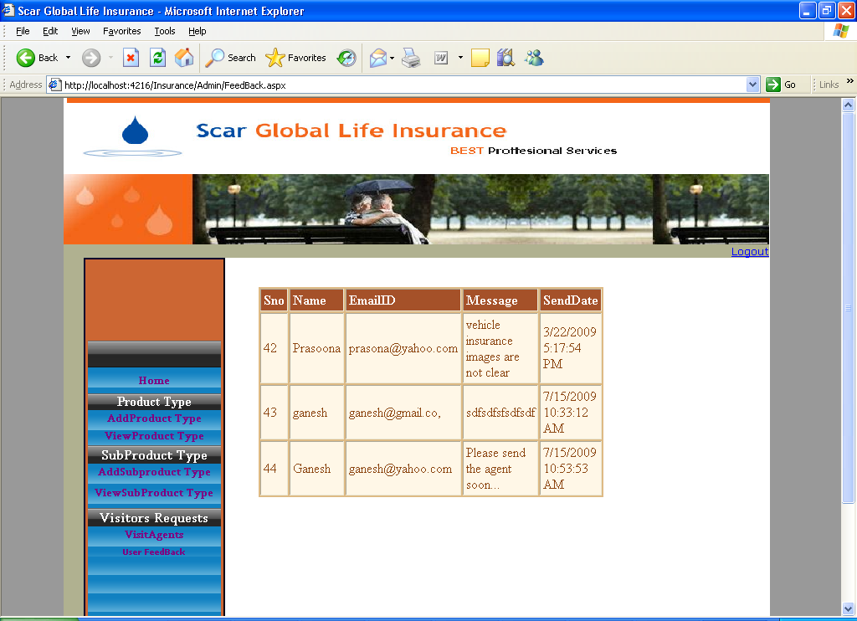

SOURCE CODE

In this section source code of some pages is provided.

Code File: DBClass.cs

using System;
using System.Data;
using System.Data.SqlClient;
using System.Configuration;
using System.Web;
using System.Web.Security;
using System.Web.UI;
using System.Web.UI.WebControls;
using System.Web.UI.WebControls.WebParts;
using System.Web.UI.HtmlControls;

/// <summary>
/// Summary description for DBClass
/// </summary>
public class DBClass
{
private SqlConnection _conn;
public Exception ErrorDetails;
public DBClass()
{
_conn = null;
ErrorDetails = null;
}

public DBClass(SqlConnection Connection)
{
_conn = Connection;
ErrorDetails = null;
}

public SqlConnection DbConnection
{
get
{
return _conn;
}
set
{
_conn = value;
}
}

protected bool OpenConnection()
{
if (_conn == null)
{
ErrorDetails = new Exception("Connection object is not initialized");
return false;
}

if (_conn.State == ConnectionState.Open) return true;

try
{
_conn.Open();
}
catch (Exception ex)
{
ErrorDetails = ex;
return false;
}
return true;
}

protected DataTable GetData(string Qry)
{
if (!OpenConnection()) return null;

SqlDataAdapter da = new SqlDataAdapter(Qry, _conn);
DataTable dt=new DataTable();
try
{
da.Fill(dt);
}
catch (Exception ex)
{
ErrorDetails = ex;
return null;
}
return dt;
}

public int ExecuteCommand(string strCmd)
{
/* This function is used to send Insert/Delete/Update commands
* This function returns number of records that are effected by the command.
* Returns -1, indicating that the fuction is failed.
*/

if (!OpenConnection()) return -1;

int res = 0;
SqlCommand cmd = new SqlCommand(strCmd, _conn);
try
{
res = cmd.ExecuteNonQuery();
}
catch (Exception ex)
{
ErrorDetails = ex;
res = -1;
}
return res;
}
public bool SaveData(string TableName, DataTable dt)
{
if (!OpenConnection()) return false;

string Qry=string.Format("Select * from {0}",TableName);
SqlDataAdapter da = new SqlDataAdapter(Qry, _conn);
SqlCommandBuilder cb = new SqlCommandBuilder(da);
da.DeleteCommand = cb.GetDeleteCommand();
da.InsertCommand = cb.GetInsertCommand();
da.UpdateCommand = cb.GetUpdateCommand();
try
{
da.Update(dt);
}
catch(Exception ex)
{
ErrorDetails = ex;
return false;
}
return true;
}

public DataTable GetIndustries()
{
return GetData("Select * from MasterIndustries");
}

public DataTable GetOccupations()
{
return GetData("Select * from MasterOccupations");
}

public DataTable GetInsurers()
{
return GetData("Select * from MasterInsurers");
}

public DataTable GetStates()
{
return GetData("Select * from MasterStates");
}

public DataTable GetRelations()
{
return GetData("Select * from MasterRelations");

Code File: MyF.cs

using System;
using System.Data;
using System.Configuration;
using System.Web;
using System.Web.Security;
using System.Web.UI;
using System.Web.UI.WebControls;
using System.Web.UI.WebControls.WebParts;
using System.Web.UI.HtmlControls;

/// <summary>
/// Summary description for MyF
/// </summary>
public class MyF
{
public MyF()
{
//
// TODO: Add constructor logic here
//
}

public static string GetString(object v)
{
if (v == DBNull.Value || v == null)
return "";

return v.ToString();
}

public static int GetInt(object v)
{
if (v == DBNull.Value || v == null)
return 0;

int r = 0;
try
{
r=int.Parse(v.ToString());
}
catch
{
r = 0;
}
return r;
}

public static short GetShort(object v)
{
if (v == DBNull.Value || v == null)
return 0;

short r = 0;
try
{
r = short.Parse(v.ToString());
}
catch
{
r = 0;
}
return r;
}

public static double GetDouble(object v)
{
if (v == DBNull.Value || v == null)
return 0;

double r = 0;

try
{
r = double.Parse(v.ToString());
}
catch
{
r = 0;
}
return r;
}

public static string GetDateString(object v)
{
if (v == DBNull.Value || v == null)
return "";

string r ="";
try
{
DateTime d=DateTime.Parse(v.ToString());
r = d.ToString("dd-MMM-yyyy");
}
catch
{
r = "";
}
return r;
}

public static bool IsValidDate(string v)
{
if (v.Trim()=="")
return false;

bool r = true;
try
{
DateTime d = DateTime.Parse(v);
r = true;
}
catch
{
r = false;
}
return r;
} }

Login Procedure

using System;
using System.Data;
using System.Configuration;
using System.Collections;
using System.Web;
using System.Web.Security;
using System.Web.UI;
using System.Web.UI.WebControls;
using System.Web.UI.WebControls.WebParts;
using System.Web.UI.HtmlControls;
using System.Data.SqlClient;

public partial class LoginControl : System.Web.UI.UserControl
{
protected void Page_Load(object sender, EventArgs e)
{
msgLbl.Text = "";
}

protected void Login1_Authenticate(object sender, AuthenticateEventArgs e)
{
string userid = Login1.UserName;
string pwd = Login1.Password;

SqlConnection conn = new SqlConnection(ConfigurationManager.ConnectionStrings["dbcstr"].ConnectionString);
AdminClass ac = new AdminClass();
ac.DbConnection =conn;
if (ac.isLoginOk(userid,pwd))
{
e.Authenticated = true;
FormsAuthentication.SetAuthCookie(userid, false);
Response.Redirect("admin/default.aspx");
//FormsAuthentication.RedirectFromLoginPage(userid, false);
}
else
{
if (ac.ErrorDetails!=null) msgLbl.Text = ac.ErrorDetails.Message;
e.Authenticated = false;
}
}
}

Code File: Articles.aspx

using System;
using System.Data;
using System.Configuration;
using System.Web;
using System.Web.Security;
using System.Web.UI;
using System.Web.UI.WebControls;
using System.Web.UI.WebControls.WebParts;
using System.Web.UI.HtmlControls;

public partial class _Default : System.Web.UI.Page
{
protected void Page_Load(object sender, EventArgs e)
{
ShowData();
}

private void ShowData()
{
AdminClass ac = new AdminClass();
ac.DbConnection = MyGlobals.dbc;
DataTable dt=ac.GetAllArticles();
GridView1.DataSource=dt;
GridView1.DataBind();
}
}

Code File: ManageArticles.aspx

using System;
using System.Data;
using System.Configuration;
using System.Collections;
using System.Web;
using System.Web.Security;
using System.Web.UI;
using System.Web.UI.WebControls;
using System.Web.UI.WebControls.WebParts;
using System.Web.UI.HtmlControls;

public partial class Admin_ManageArticles : System.Web.UI.Page
{
protected void Page_Load(object sender, EventArgs e)
{
if (!IsPostBack)
{
ShowData();
}
lblMsg.Text = "";
}

private void ShowData()
{
System.Data.SqlClient.SqlConnection c = new System.Data.SqlClient.SqlConnection(ConfigurationManager.ConnectionStrings["dbcstr"].ConnectionString);
AdminClass ac = new AdminClass();
ac.DbConnection = c;
DataTable dt = new DataTable();
dt = ac.GetAllArticles();
if (dt == null)
{
Trace.Warn(ac.ErrorDetails.Message);
}
GridView1.DataSource = dt;
GridView1.DataBind();
}
}
protected void btnDel_Click(object sender, EventArgs e)
{
string delList = GetSelectedItems();
if (delList.Trim() == "") return;
System.Data.SqlClient.SqlConnection c = new System.Data.SqlClient.SqlConnection(ConfigurationManager.ConnectionStrings["dbcstr"].ConnectionString);
AdminClass ac = new AdminClass();
ac.DbConnection = c;
if (ac.DeleteArticles(delList))
{
ShowData();
}
else
{
lblMsg.Text = "Unable to delete. Please try again.";
if (ac.ErrorDetails != null)
{
Trace.Warn(ac.ErrorDetails.Message);
lblMsg.Text += "<br>" + ac.ErrorDetails.Message;
}
}
}

private string GetSelectedItems()
{
string res = "";
foreach (GridViewRow gvr in GridView1.Rows)
{
CheckBox chkbx = (CheckBox)gvr.FindControl("CheckBox1");
if (chkbx != null && chkbx.Checked)
{
string data = GridView1.DataKeys[gvr.RowIndex].Value.ToString();
if (res.Trim() != "") res += ",";
res += string.Format("{0}", data);
}
}
return res; } }

Code File: ManageIndustries.aspx

using System;
using System.Data;
using System.Configuration;
using System.Web;
using System.Web.Security;
using System.Web.UI;
using System.Web.UI.WebControls;
using System.Web.UI.WebControls.WebParts;
using System.Web.UI.HtmlControls;

public partial class ManageIndustries : System.Web.UI.Page
{
protected void Page_Load(object sender, EventArgs e)
{
if (!IsPostBack)
{
ShowData();
}
lblMsg.Text = "";
}

private void ShowData()
{
System.Data.SqlClient.SqlConnection c = new System.Data.SqlClient.SqlConnection(ConfigurationManager.ConnectionStrings["dbcstr"].ConnectionString);
AdminClass ac = new AdminClass();
ac.DbConnection = c;
DataTable dt = new DataTable();
dt = ac.GetAllIndustries();
if (dt == null)
{
Trace.Warn(ac.ErrorDetails.Message);
}
GridView1.DataSource = dt;
GridView1.DataBind();

}

protected void btnDel_Click(object sender, EventArgs e)
{
string delList = GetSelectedItems();
if (delList.Trim() == "") return;
System.Data.SqlClient.SqlConnection c = new System.Data.SqlClient.SqlConnection(ConfigurationManager.ConnectionStrings["dbcstr"].ConnectionString);
AdminClass ac = new AdminClass();
ac.DbConnection = c;
if (ac.DeleteIndustries(delList))
{
ShowData();
}
else
{
lblMsg.Text = "Unable to delete. Please try again.";
if (ac.ErrorDetails != null)
{
Trace.Warn(ac.ErrorDetails.Message);
lblMsg.Text += "<br>" + ac.ErrorDetails.Message;
}
}
}

private string GetSelectedItems()
{
string res = "";
foreach (GridViewRow gvr in GridView1.Rows)
{
CheckBox chkbx=(CheckBox) gvr.FindControl("CheckBox1");
if (chkbx != null && chkbx.Checked)
{
string data = GridView1.DataKeys[gvr.RowIndex].Value.ToString();
if (res.Trim() != "") res += ",";
res += string.Format("'{0}'",data);
}
}

return res;
}
protected void btnAdd_Click(object sender, EventArgs e)
{
System.Data.SqlClient.SqlConnection c = new System.Data.SqlClient.SqlConnection(ConfigurationManager.ConnectionStrings["dbcstr"].ConnectionString);
AdminClass ac = new AdminClass();
ac.DbConnection = c;
if (ac.AddIndustry(txtNewData.Text.Trim()))
{
txtNewData.Text = "";
ShowData();
}
else
{
lblMsg.Text = "Unable to Add. Please try again.";
if (ac.ErrorDetails != null)
{
Trace.Warn(ac.ErrorDetails.Message);
lblMsg.Text += "<br>" + ac.ErrorDetails.Message;
}
}
}
}

Code File: ManageInsurers.aspx

using System;
using System.Data;
using System.Configuration;
using System.Web;
using System.Web.Security;
using System.Web.UI;
using System.Web.UI.WebControls;
using System.Web.UI.WebControls.WebParts;
using System.Web.UI.HtmlControls;

public partial class ManageInsurers : System.Web.UI.Page
{
protected void Page_Load(object sender, EventArgs e)
{
if (!IsPostBack)
{
ShowData();
}
lblMsg.Text = "";
}

private void ShowData()
{
System.Data.SqlClient.SqlConnection c = new System.Data.SqlClient.SqlConnection(ConfigurationManager.ConnectionStrings["dbcstr"].ConnectionString);
AdminClass ac = new AdminClass();
ac.DbConnection = c;
DataTable dt = new DataTable();
dt = ac.GetAllInsurers();
if (dt == null)
{
Trace.Warn(ac.ErrorDetails.Message);
}
GridView1.DataSource = dt;
GridView1.DataBind();

}

protected void btnAdd_Click(object sender, EventArgs e)
{
System.Data.SqlClient.SqlConnection c = new System.Data.SqlClient.SqlConnection(ConfigurationManager.ConnectionStrings["dbcstr"].ConnectionString);
AdminClass ac = new AdminClass();
ac.DbConnection = c;
if (ac.AddInsurer(txtNewData.Text.Trim()))
{
txtNewData.Text = "";
ShowData();
}
else
{
lblMsg.Text = "Unable to Add. Please try again.";
if (ac.ErrorDetails != null)
{
Trace.Warn(ac.ErrorDetails.Message);
lblMsg.Text += "<br>" + ac.ErrorDetails.Message;
}
}
}
protected void btnDel_Click(object sender, EventArgs e)
{
string delList = GetSelectedItems();
if (delList.Trim() == "") return;
System.Data.SqlClient.SqlConnection c = new System.Data.SqlClient.SqlConnection(ConfigurationManager.ConnectionStrings["dbcstr"].ConnectionString);
AdminClass ac = new AdminClass();
ac.DbConnection = c;
if (ac.DeleteInsurers(delList))
{
ShowData();
}
else
{
lblMsg.Text = "Unable to delete. Please try again.";
if (ac.ErrorDetails != null)
{
Trace.Warn(ac.ErrorDetails.Message);
lblMsg.Text += "<br>" + ac.ErrorDetails.Message;
}
}
}

private string GetSelectedItems()
{
string res = "";
foreach (GridViewRow gvr in GridView1.Rows)
{
CheckBox chkbx = (CheckBox)gvr.FindControl("CheckBox1");
if (chkbx != null && chkbx.Checked)
{
string data = GridView1.DataKeys[gvr.RowIndex].Value.ToString();
if (res.Trim() != "") res += ",";
res += string.Format("'{0}'", data);
}
}
return res;
}
}

Code File: ManageOccupations.aspx

using System;
using System.Data;
using System.Configuration;
using System.Web;
using System.Web.Security;
using System.Web.UI;
using System.Web.UI.WebControls;
using System.Web.UI.WebControls.WebParts;
using System.Web.UI.HtmlControls;

public partial class ManageOccupations : System.Web.UI.Page
{
protected void Page_Load(object sender, EventArgs e)
{
if (!IsPostBack)
{
ShowData();
}
lblMsg.Text = "";
}
private void ShowData()
{
System.Data.SqlClient.SqlConnection c = new System.Data.SqlClient.SqlConnection(ConfigurationManager.ConnectionStrings["dbcstr"].ConnectionString);
AdminClass ac = new AdminClass();
ac.DbConnection = c;
DataTable dt = new DataTable();
dt = ac.GetAllOccupations();
if (dt == null)
{
Trace.Warn(ac.ErrorDetails.Message);
}
GridView1.DataSource = dt;
GridView1.DataBind();
}

protected void btnDel_Click(object sender, EventArgs e)
{
string delList = GetSelectedItems();
if (delList.Trim() == "") return;
System.Data.SqlClient.SqlConnection c = new System.Data.SqlClient.SqlConnection(ConfigurationManager.ConnectionStrings["dbcstr"].ConnectionString);
AdminClass ac = new AdminClass();
ac.DbConnection = c;
if (ac.DeleteOccupations(delList))
{
ShowData();
}
else
{
lblMsg.Text = "Unable to delete. Please try again.";
if (ac.ErrorDetails != null)
{
Trace.Warn(ac.ErrorDetails.Message);
lblMsg.Text += "<br>" + ac.ErrorDetails.Message;
}
}
}

private string GetSelectedItems()
{
string res = "";
foreach (GridViewRow gvr in GridView1.Rows)
{
CheckBox chkbx = (CheckBox)gvr.FindControl("CheckBox1");
if (chkbx != null && chkbx.Checked)
{
string data = GridView1.DataKeys[gvr.RowIndex].Value.ToString();
if (res.Trim() != "") res += ",";
res += string.Format("'{0}'", data);
}
}

return res;
}

protected void btnAdd_Click(object sender, EventArgs e)
{
System.Data.SqlClient.SqlConnection c = new System.Data.SqlClient.SqlConnection(ConfigurationManager.ConnectionStrings["dbcstr"].ConnectionString);
AdminClass ac = new AdminClass();
ac.DbConnection = c;
if (ac.AddOccupation(txtNewData.Text.Trim()))
{
txtNewData.Text = "";
ShowData();
}
else
{
lblMsg.Text = "Unable to Add. Please try again.";

if (ac.ErrorDetails != null)
{
Trace.Warn(ac.ErrorDetails.Message);
lblMsg.Text += "<br>" + ac.ErrorDetails.Message;
}
}
}
}

7.0 TESTING

Testing is the major quality measure employed during the software engineering development. Its basic function is to detect error in the software. Testing is necessary for the proper functioning of the system. Testing has to be done at four levels

Unit Testing

Unit testing focuses verification effort on the smallest unit of the software ,design the module. Here ,using the detail design as a guide ,important control paths are tested to uncover errors within the boundary of the module. Unit testing is always white-box oriented, and the step can be conducted in parallel for multiple modules. .

Integration Testing

Integration testing is a systematic technique for constructing the program structure while at the same time conducting tests to uncover errors , associated with interfacing .The objective is to take the unit tested modules and build program structure that has been directed by the design.

Validation Testing

Validation testing demonstrates the traces the requirements of the software .This can be achieved through a series of black box tests.

System Testing

System testing is actually a series of different tests whose primary purpose is to fully exercise the computer-based system . Although each test has a different purpose, all works should verify that all system elements have been properly integrated and perform allocated functions. The various tests include recovery testing , stress testing , perform testing.

Maintenance and Implementation

- Corrective maintenance

This acts to correct errors that are uncovered after the software is in use.

- Adaptive Maintenance

This is applied when changes is the external environment precipitate modifications to software.

- Preventive maintenance

This improves future maintainability and reliability and provides basis for future enhancements.

MODULE/SECTION: Login
Section ID: L

Test Case: Mandatory test (Unit test)
Main Test case ID | Element Name
L1 | User ID
L2 | Password

Test Result
Test case id | Element Name | Element Type | Input | Expected result | Actual Result | Test Result
L1-1 | User ID | Textbox | -no input- | Displays error | Error displayed | Passed
L1-2 |  |  | Haritha | No error | No error | Passed
L2-1 | Password | Textbox | -no input- | Displays error | Error displayed | Passed
L2-2 |  |  | ***** (password “hello” is entered) | Data should not be displayed, but only * characters | Data is not displayed but only * characters are displayed | Passed

8.0 SCOPE OF FUTURE ENHANCEMENTS

After finishing the requirements for phase-1 of the development the remaining estimated modules will be developed. The following enhancements may be added to the existing modules.

- Add new Administrators
- Enhancement of search options after completion of the pahse-2

These features are estimated depends upon the requirements of the client in phase-2. So, these modifications require completion of the pahse-2 development of the project.

9.0 CONCLUSION

The developed project fulfills the website facilities estimated for pahse-1 development and as per all the currently addressed requirements of the client (stakeholder).

Development team will provide

- Uploading and trail running of the website.
- Plan to avoid/handle unexpected damages
- Probable list of modifications that will guide the pahse-2 development of the project.

10.0 BIBLIOGRAPHY

1. Ian Somerville, Principles of Software Engineering ,4 Edition .

- Roger S. Pressman ,Software Engineering – A Practitioner’s Approach .

- IEEE, IEEE Software Standards , IEEE Press ,1989 .

- Net Framework Essentials By O’Really

5. Beginning ASP.Net By Wrox Publishing
(VB.Net & ASP.Net &C#)

6. MS SQL Server By Wrox & Microsoft Press.

